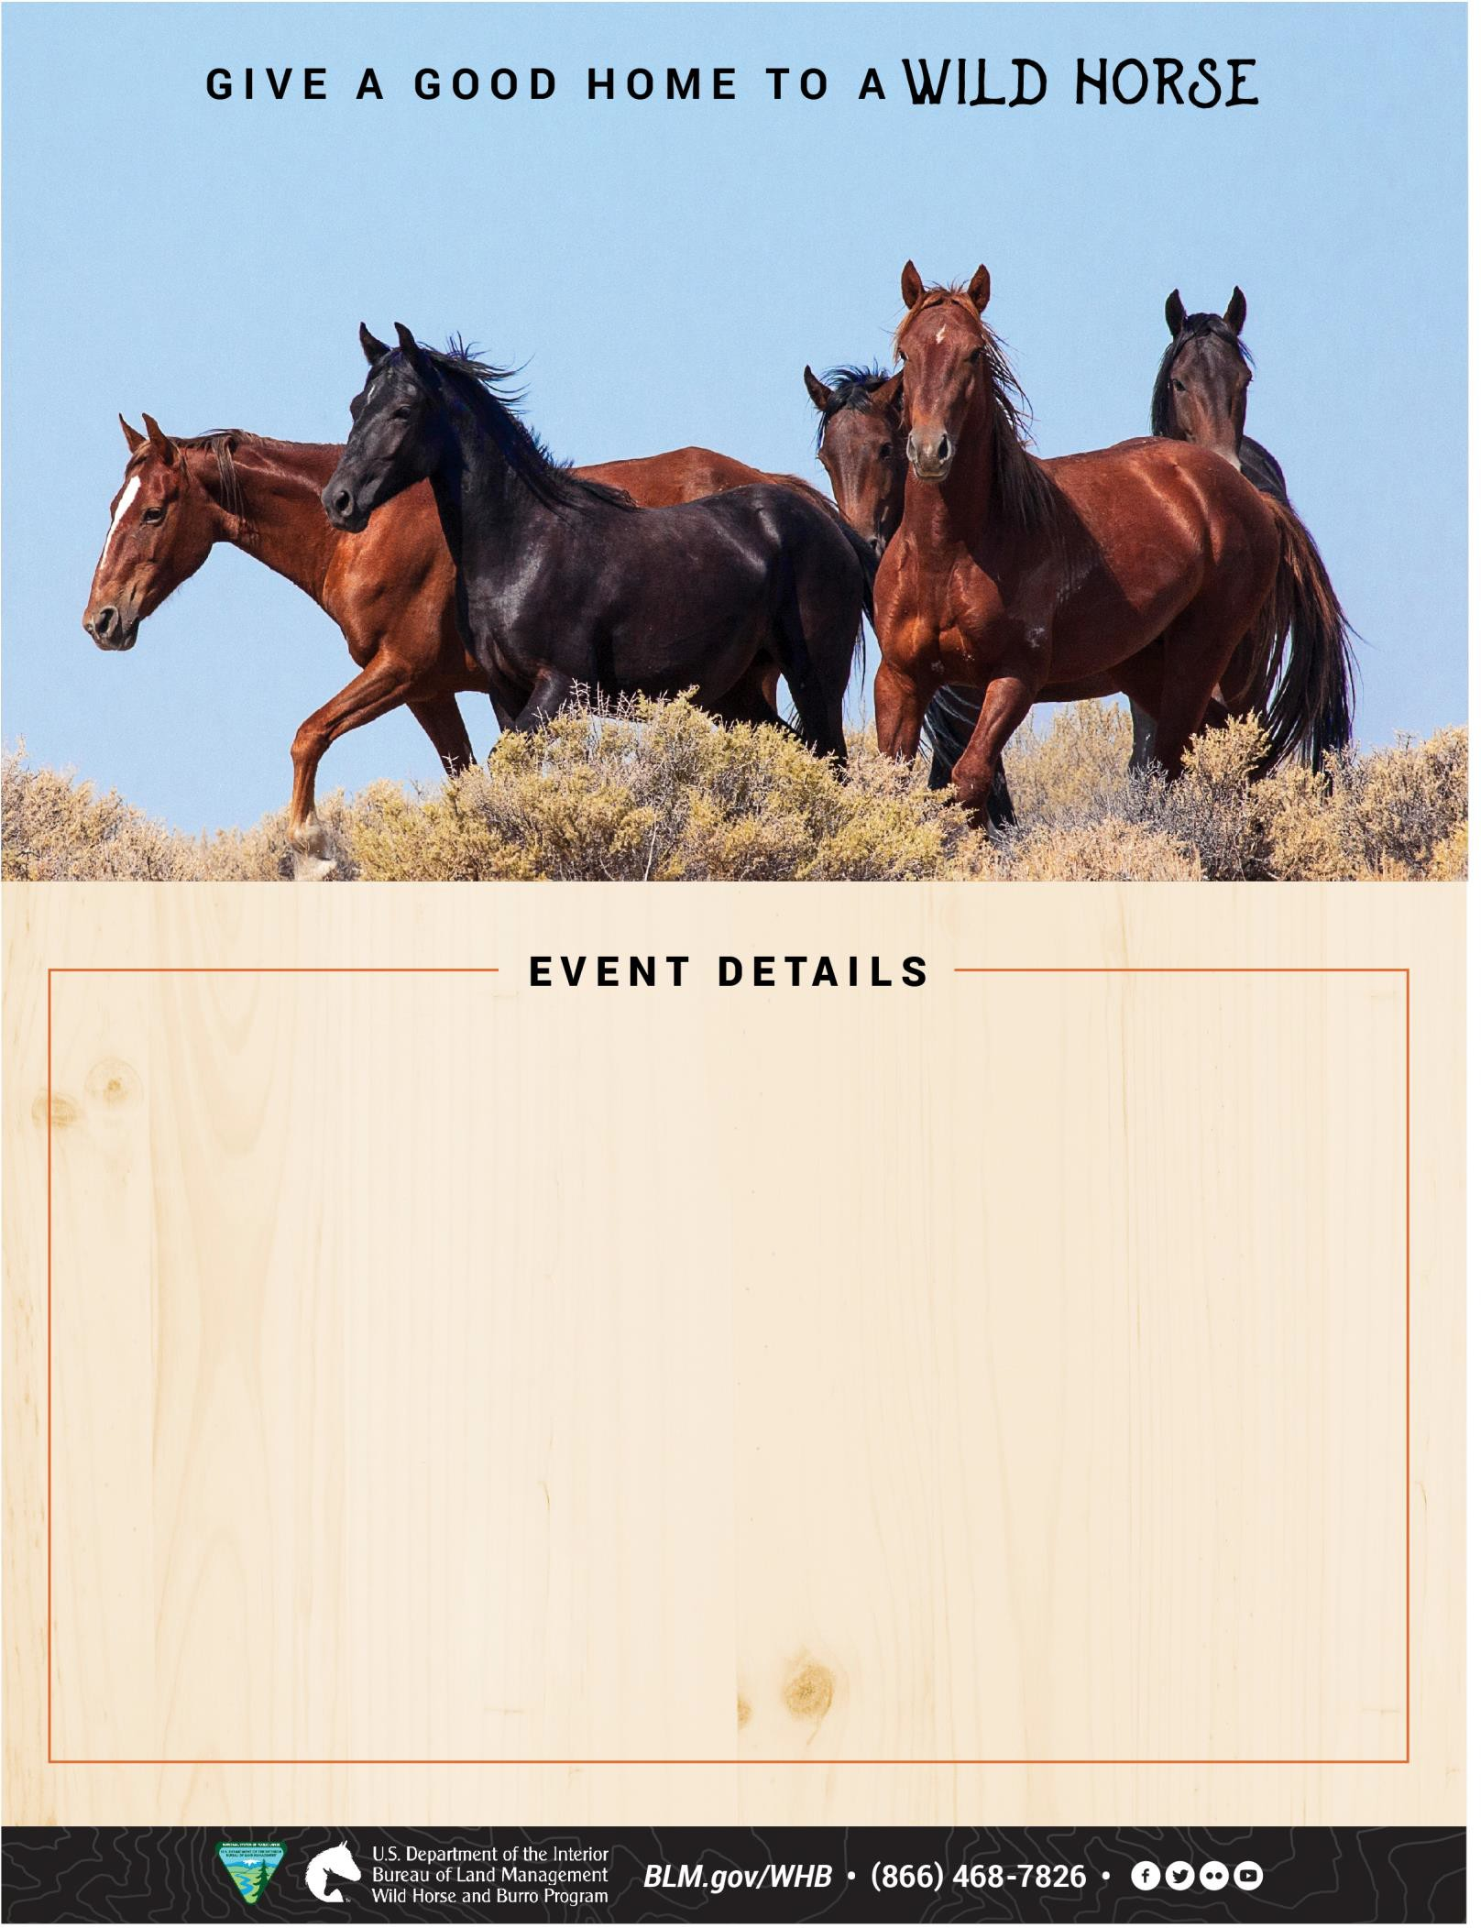
CARTHAGE, MO

November 7 - 9, 2025

APPOINTMENT PREFERRED
Civil War Arena
11838 Civil War Road
Carthage, MO 64836

$125 minimum fee for animals adopted
$25 minimum fee for animals purchased

Thursday, November 7, 2025
OLC Pick-Ups from: 8 a.m. – 5 p.m. CDT

Friday, November 8, 2025
Appointments from: 8 a.m. – 5 p.m. CDT

Saturday, November 9, 2025
Appointments from: 8 a.m. – 1 p.m. CDT

Email Appointment Request:
BLM_ES_NSDO_WHB@blm.gov
One-hour increments for both days (five appointments per hour)
Please indicate your TOP 3 preferred time slots prior to event.
Come and adopt a horse or learn more about the program.

