

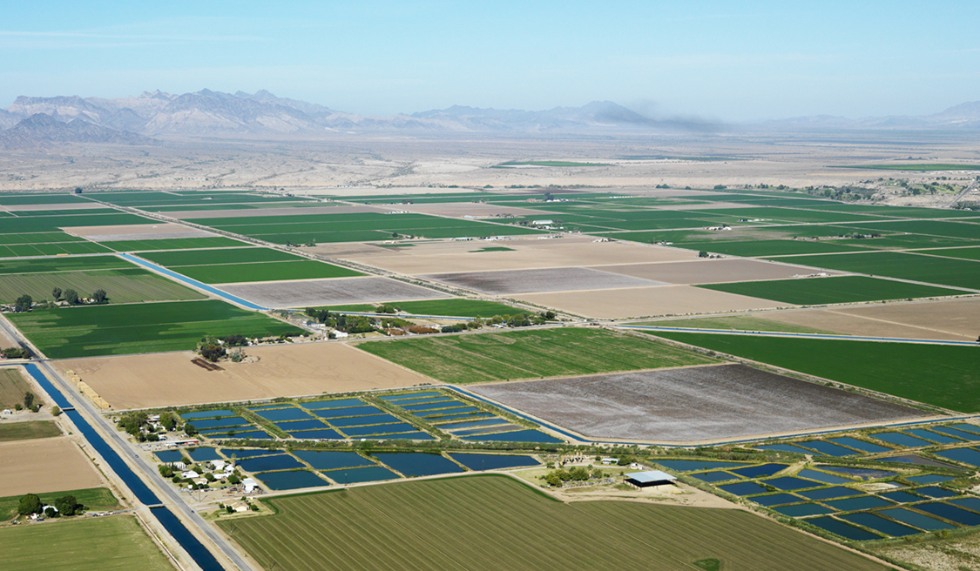
Protect against costly infrastructure failures and water outages
Support economic development in your community
Ensure that your community has safe and reliable water now and in the future
Assess the current viability of your local utilities and plan for the future

[Workshop date]

RURAL AND SMALL SYSTEMS SUSTAINABLE UTILITY MANAGEMENT WORKSHOP
This workshop will help utilities address a full range of challenges and move toward sustainable management of their operations and infrastructure.
Hosting Association Name
Workshop Location
Registration Information
- How to deliver increasingly efficient, and higher quality services
- How to improve long-term sustainability and increase resiliency
- How to use the Small Systems Guidebook to Effective Utility Management to make improvements at your system
Utilities will learn how to make improvements in the ten key management areas, at a pace consistent with their most pressing challenges.

Workshop Agenda
- Introductions & Workshop Objectives | - Improving Outcomes Discussion
- Overview of Key Management Areas | - Practices, Tools, and Measuring Results
- Utility “Self-Assessment” Exercise | - Creating an Action Plan
- Working Lunch | - Feedback Session

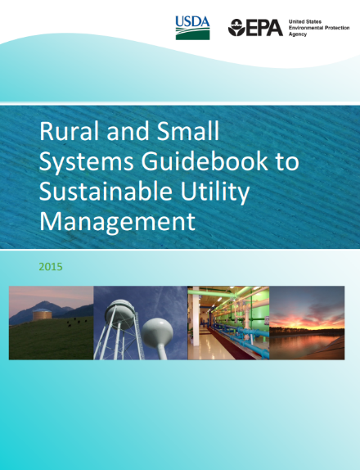
Resources Covered at the Workshop
The Environmental Protection Agency (EPA) and United States Department of Agriculture (USDA) have worked with utilities, water associations, and technical assistance providers to create materials that help utilities address challenges and capture improvement opportunities. These materials include the Rural and Small Systems Guidebook to Sustainable Utility Management and the Workshop in a Box. You can find these resources on USDA and EPA’s websites, and you can access them through your local technical assistance providers.
http://water.epa.gov/infrastructure/sustain/watereum.cfm
http://www.rd.usda.gov/programs-services/services/sustainable-management-tools
Ten Key Management Areas
The workshops and Guidebook are built around ten key management areas. These ten areas of sustainable utility management help utility and community leaders assess utility health, discuss potential community impacts, and prioritize future activities based on what is best for the utility and the community.
- Financial Viability | - Infrastructure Stability
- Operational Resiliency | - Product Quality
- Employee and Leadership Development | - Customer Satisfaction
- Water Resource Adequacy | - Stakeholder Understanding and Support
- Community Sustainability and Economic Development | - Operational Optimization

