

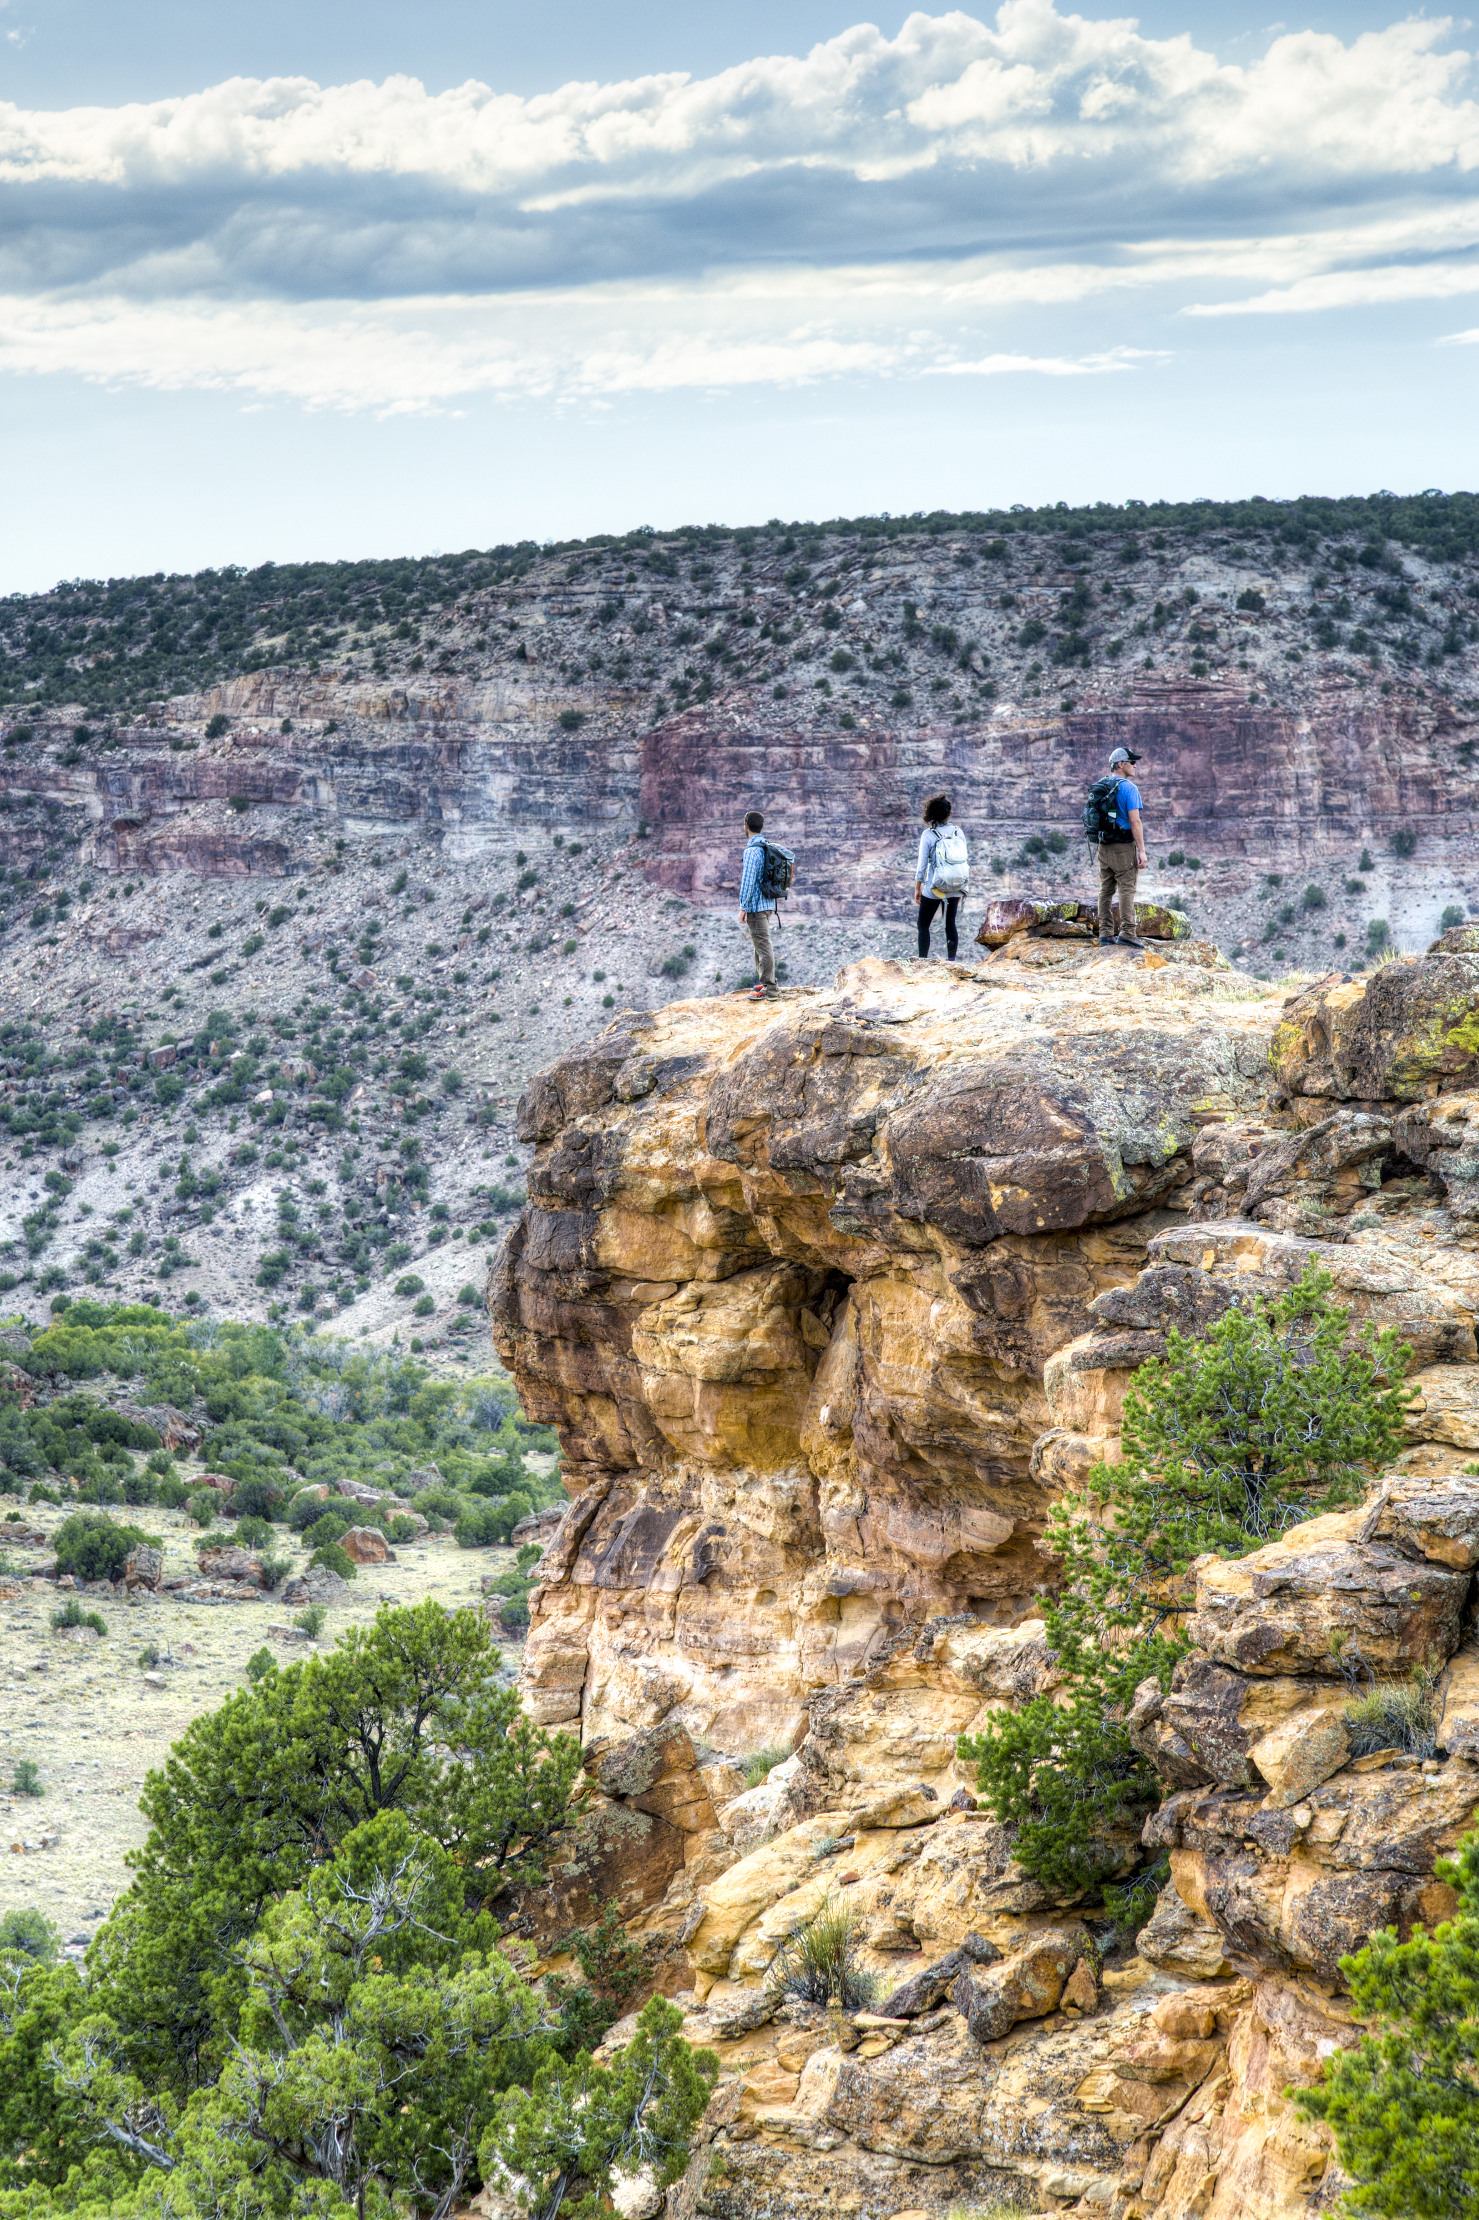
Colorado
Dominguez - Escalante
National Conservation Area

‘
Annual Manager’s Report—Fiscal Year 2017
Table of Contents

Dominguez-Escalante Profile 2
Planning and NEPA 5
Year’s Projects and Accomplishments 8
Science 15
Resources, Objects, Values, and Stressors 17
Summary of Performance Measure 24
Manager’s Letter 25

Dominguez-Escalante NCA Profile
1

Designating Authority

Designating Authority: [Omnibus Public Lands Management Act of 2009 (Public Law 111-11)

Date of Designation: March 30, 2009

Acreage

Total Acres in Unit | 218,394 Acres
BLM Acres | 210,149 Acres
Other Federal Acres | 0
State Acres* | 1,965 Acres
Private Acres* | 6,280 Acres
*State and Private acres are not part of the total unit acres

Contact Information

Unit Manager | Collin Ewing
Phone | 970-244-3049
E-mail | cewing@blm.gov
Mailing Address | 2815 H Road, Grand Junction, CO 81501
Field Office Name | Grand Junction
District Office Name | Southwest
State Office Name | Colorado

Budget

Total Fiscal Year 2017 Budget | $733,000
Subactivity 1711 (Monuments & NCAs appropriation) | $477,000
Other BLM Programs Contributions | $212,000
Other Funding (non-appropriated funds) | $40,000 State OHV grant  $4,000 grazing fees

Map of Dominguez-Escalante National Conservation Area

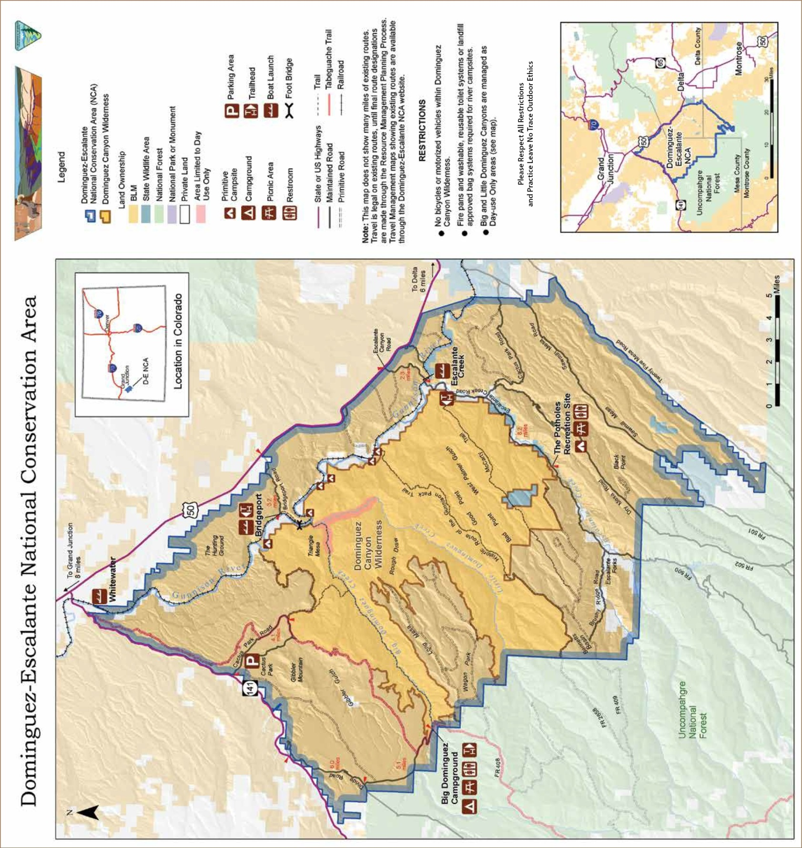

Staffing

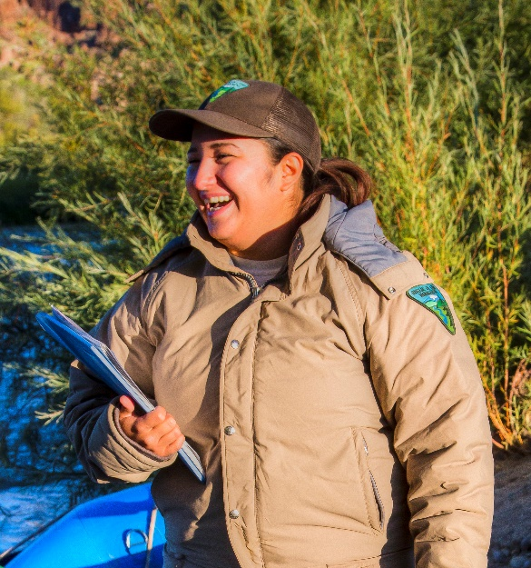
The permanent staff of the Dominguez-Escalante NCA (D-E NCA; the NCA) consists of an NCA Manager, a science ecologist shared with McInnis Canyons NCA (MCNCA), a law enforcement officer shared with MCNCA, a National Conservation Lands Specialist shared with MCNCA, and a Natural Resources Specialist. In FY 2017, seasonal staff included two river rangers shared with the Uncompahgre Field Office (UFO), two Off-Highway Vehicle Trail Crew members shared with MCNCA, two Ecology interns shared with MCNCA and two recreation maintenance interns shared with MCNCA and Grand Junction Field Office (GJFO).

The NCA receives special recreation permit administration, facilities maintenance and other program support from the GJFO and UFO, primarily in the areas of visitor services and contact; geology and paleontology; archaeology; realty; range management; wildlife biology; ecology; weed management; geographic information systems (GIS); and soil, water and air quality.

The Bureau of Land Management (BLM) partners with Colorado Canyons Association (CCA) to hire one NCA Stewardship Coordinator and one NCA Education coordinator who develop and implement volunteer stewardship and youth education programs for MCNCA and D-E NCA. 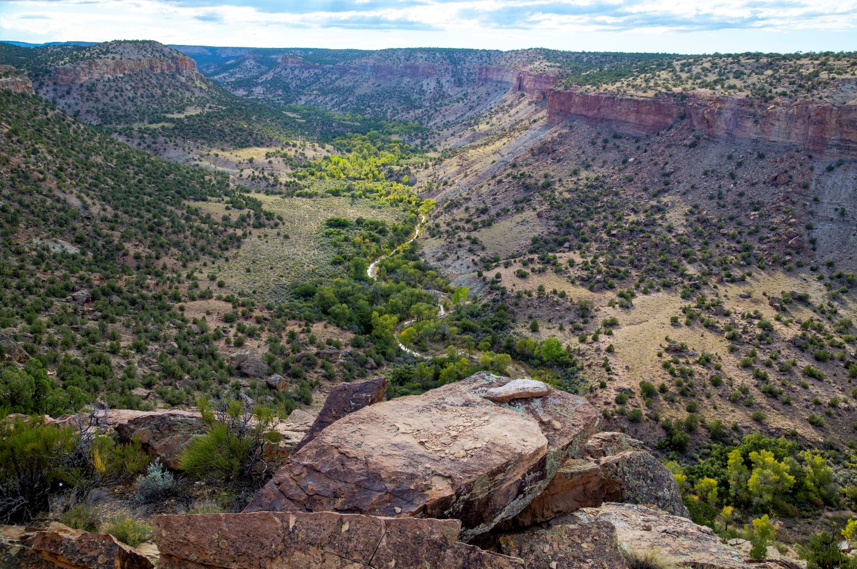

Planning and NEPA
2

Status of the Resource Management Plan

In 2017 the Dominguez Escalante NCA Approved Resource Management Plan and Record of Decision were completed. This was the culmination of 7 years of hard work by BLM staff and engaged community members to strike a balance between protection of the NCA resources and preserving traditional uses and recreation. This plan gives comprehensive guidance for the management of the NCA for the next 20 years. The news release is included below.


News Release

For Immediate Release: January 12, 2017
Contact: Chris Joyner, BLM Public Affairs Specialist, 970-210-2126

BLM Sets the Course for Managing the Dominguez-Escalante National Conservation Area

GRAND JUNCTION, Colo. - The Bureau of Land Management finalized the plan for the 210,000-acre Dominguez-Escalante National Conservation Area, including the Dominguez Canyon Wilderness, by signing a Record of Decision for the area this week. The Dominguez-Escalante NCA includes portions of Mesa, Delta and Montrose counties.
Known for its breathtaking and uniquely Colorado scenery, the Dominguez-Escalante NCA holds geological and paleontological resources tracing back 600 million years. There are also many cultural and historic sites located within the NCA. Today, the Ute Tribes consider these pinyon juniper-covered lands an important connection to their ancestral past. Dominguez-Escalante provides one of Colorado’s most recognizable landscapes, with red rock canyons, the Gunnison River, and the picturesque Dominguez and Escalante canyons.

“Thanks to the hard work of many local community members and elected officials, this plan strikes the right balance in protecting sensitive resources, providing outstanding recreation opportunities and continuing historical uses in the NCA,” said Collin Ewing, NCA Manager. “The BLM is fortunate to manage such an incredible landscape that enjoys so much support from the local community.”
Visitors will continue to enjoy high quality recreational experiences such as dispersed camping, equestrian, climbing, boating, hiking, mountain biking, off-highway vehicle use and access to wilderness. The plan calls for enhancements to recreation, including motorized trail improvements in Cactus Park to improve off-road recreation through trail improvements and rerouting to make motorized routes sustainable. Traditional activities like livestock grazing and hunting will continue within Dominguez-Escalante.

"Under this plan, the BLM estimates that recreation within the NCA will provide $3.4 million in annual labor income to the local economy and a net benefit of almost $6 million to recreation users,” Ewing said.

The plan designates two new areas for the protection of rare plants and paleontological resources; with these two areas, the NCA now has a total of four Areas of Critical Environmental Concern covering 9,000 acres.

The plan builds on a history of broad local support for Dominguez-Escalante, which was designated by the U.S. Congress in 2009. Representatives from local communities contributed time and resources toward developing the Proposed Resource Management Plan. In addition to public comment and participation in meetings during both the scoping and draft stages of the plan, the Dominguez-Escalante Advisory Council met with the BLM and the public 38 times to delve into how to best manage this area for its special resources.

The Dominguez-Escalante NCA was designated by the 2009 Omnibus Public Lands Management Act and is part of the BLM’s National Conservation Lands. Within the boundary of the NCA, the Dominguez Canyon Wilderness provides outstanding hiking and exploring opportunities and includes scenic canyons and mesas carved in sandstone, two cascading streams, waterfalls, spectacular geologic features, ecological diversity, and archaeological and paleontological sites. The wilderness is home to desert bighorn sheep as well as rock art and historic remnants of the area’s ranching roots.

The plan is available at http://1.usa.gov/1qKkMVi.

Status of Activity Plans
Resource Management Plan Implementation Strategy
After completing the RMP, the BLM team got back to work on an implementation strategy (completed in September 2017). This complex document lays out all the workload needed to accomplish all of the actions identified in the RMP. This strategy helps the BLM prioritize annual workload, request funding from the state and Washington offices, and report accomplishments.
River campsites
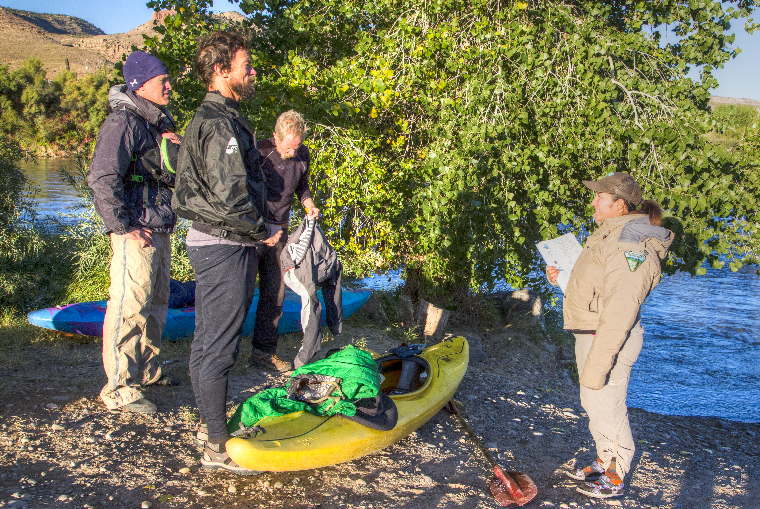The section of the Gunnison River within D-E NCA, commonly referred to as the Lower Gunnison attracts many recreational boaters and is important to the livelihood of local river outfitters. Under guidance from the recently released RMP, several campsites are being identified and designated in order to avoid user conflicts over campsites. Furthermore, weed treatment along the river corridor is being planned.

Travel management
The Resource Management Plan included a Travel Management Plan that designated routes in the NCA. Travel management route designations support resource program decisions. Some routes were designated to ensure access for visitors or outstanding recreation opportunities, while other routes were designated to protect D-E NCA resources.
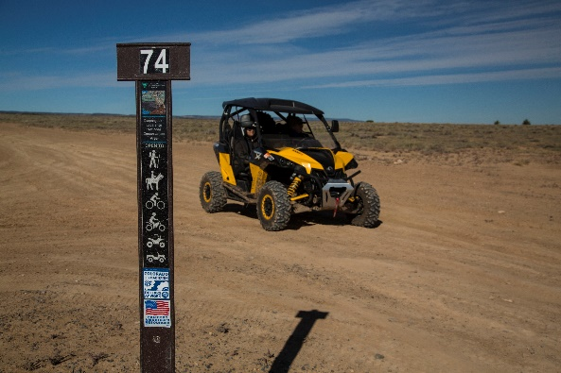
In 2017, implementation of the Travel Management Plan began for the D-E NCA. The NCA Off Highway Vehicle (OHV) crew installed over 150 signs on routes open to motorized use to help visitors navigate in the NCA. Along with installing route signs, the OHV crew installed kiosks and developed displays to help visitors learn about NCA resources and opportunities.

The OHV crew is funded through a grant from Colorado Parks and Wildlife's trail program. Money from the sale of OHV stickers is used to help land managers maintain trails educate users about sustainable OHV use and implement travel management plans. The NCA OHV crew works in both D-E NCA and MCNCA. Most of the work this year was in D-E NCA implementing the travel management plan.

Key National Environmental Policy Act Actions and/or Project Authorizations

Local Recreation Businesses Thrive in D-E NCA
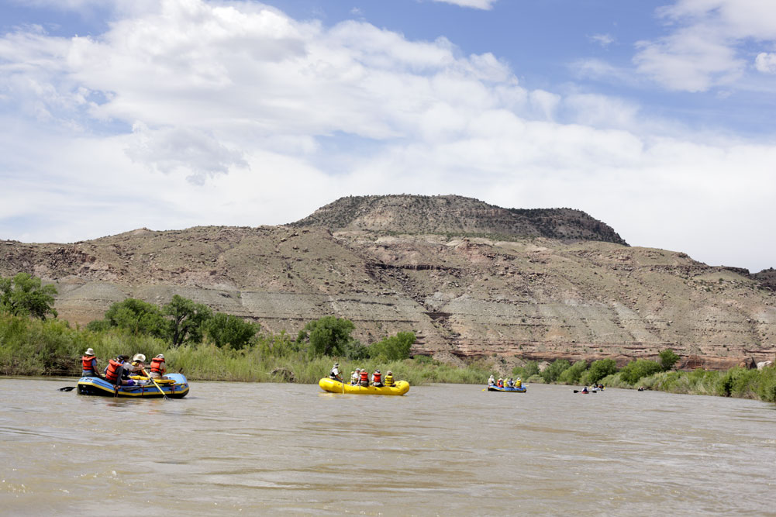
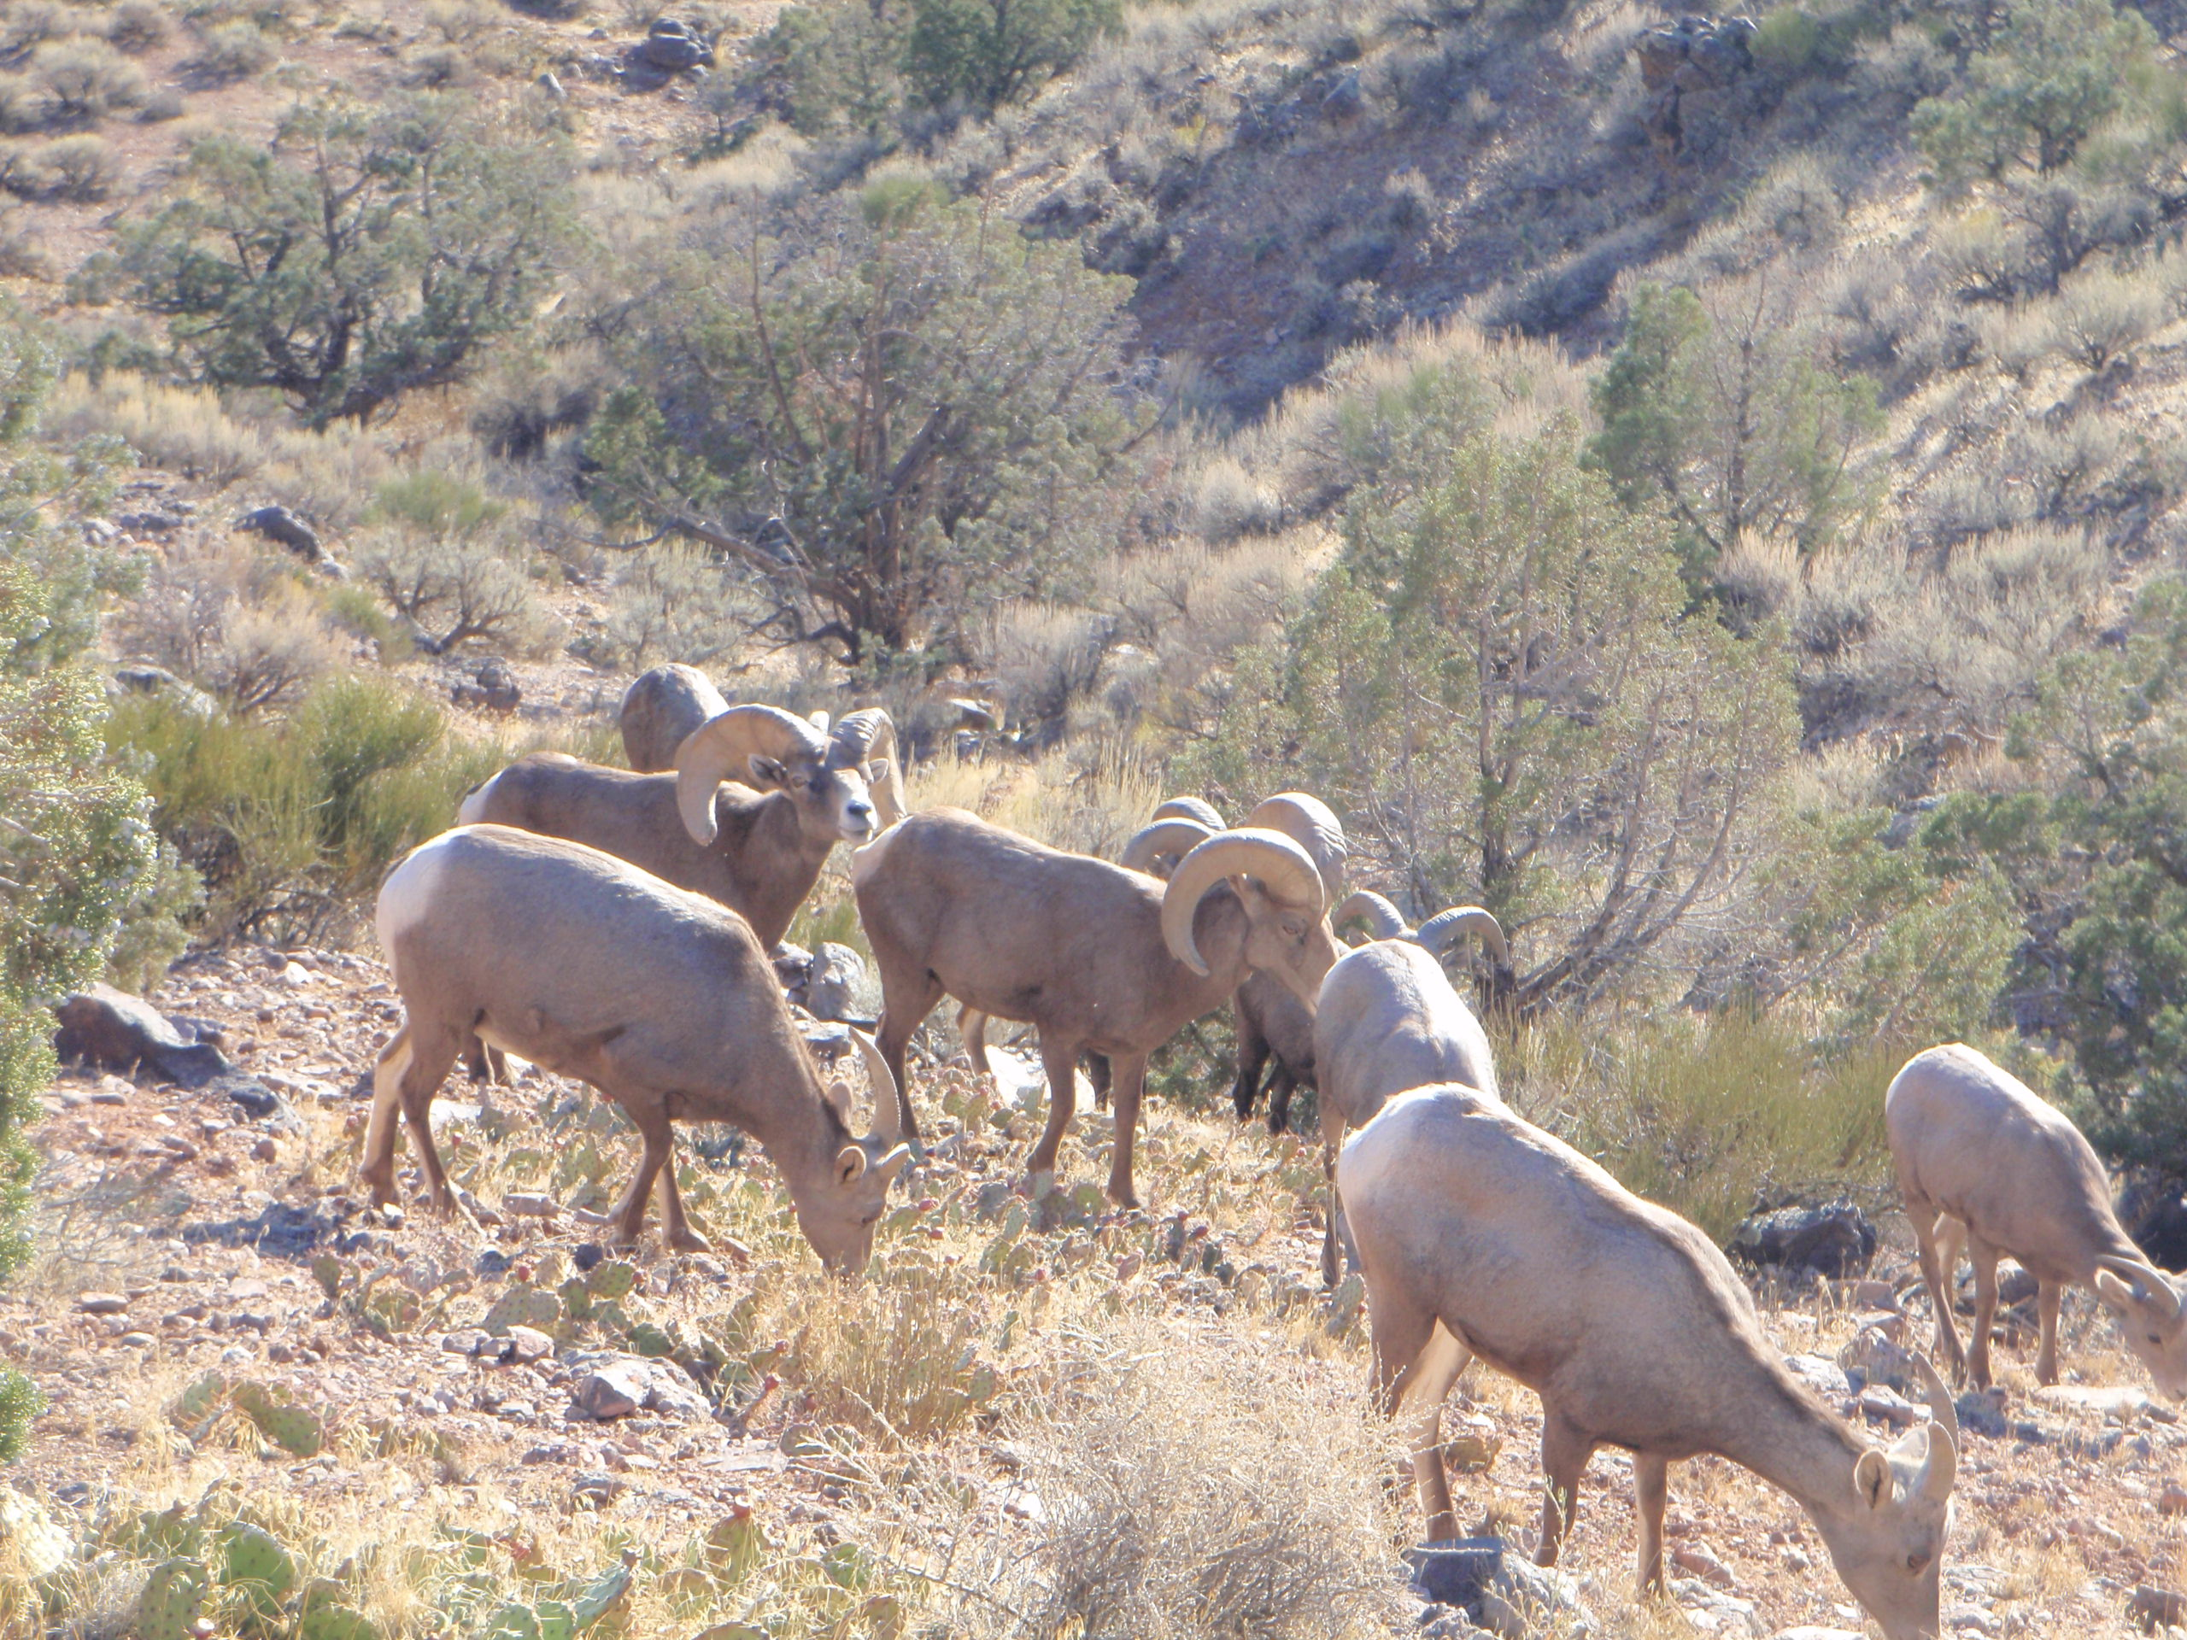Local Recreation businesses such as outfitters, event organizers, and tour operators, operating under Special Recreation Permits (SRPs), had a great year in the NCA in 2017. While final calendar year 2017 numbers weren't available when this report went to press, similar or bigger numbers than 2016 are expected. The 17 businesses that use the NCA for part of their operations reported $130,000 in gross receipts and brought 1,600 people out to the NCA who may not have had the means or the skills to recreate in the NCA without the services offered by the businesses. Most of this economic activity can be attributed to river rafting and canoeing outfitters, while the remainder offer a variety of services such as big game hunting, canyoneering, paleontology tours, and special events. Hunting outfitters provide opportunities to harvest trophy elk and mule deer, and can provide an amazing experience for those folks lucky enough to draw one of Colorado's 11 once in a lifetime Desert bighorn ram tags. BLM is currently processing applications for three new businesses to operate in the NCA starting in 2018.

Managing Wildland Fire for Resource Benefit
The necessary environmental reviews were completed to manage wildland fire for resource benefit in the Black Ridge Canyons Wilderness.

New Fire Management Plan
The Upper Colorado Interagency Fire Management Unit and NCA staff developed a new Fire Management Plan that covers the D-E NCA. This plan gives overall direction for the management of fire and helps identify values at risk. The Southwest Colorado Fire Management Unit will use this same information when developing their fire management plan.

Rock Junction Jeep Event
Rock Junction is an annual event hosted by the Grand Mesa Jeep Club (GMJC) over the course of three to five days in late May or early June. GMJC conducted their first Rock Junction event in 2012. The purpose of the event is to gather four-wheel-drive enthusiasts for relaxed, non-competitive tours of a variety of Western Colorado’s 4x4 opportunities. The event utilizes trails near Montrose, Moab, Rangely, Grand Junction, and De Beque. The event accommodates utility task vehicles (UTVs) and full-size 4x4 vehicles. A GMJC representative leads each tour. The proposed routes for the guided trips include roads and trails managed by the BLM’s Grand Junction Field Office, Uncompahgre Field Office, Moab Field Office, and White River Field Office.

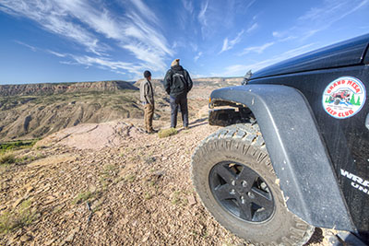

Year’s Projects and Accomplishments
3

General Accomplishments

CCA Partnership Excellence Award
The BLM awarded CCA with the Partnership Excellence Award for their work protecting National Conservation Lands in western Colorado and for their educational activities in the tri-county area near Grand Junction. DE-NCA Manager Collin Ewing and CCA executive Director Joe Neuhof travelled to Spokane, Washington, to attend the Association of Partners for Public Lands national conference where the award was presented by BLM Community Partnerships Division Chief Janet Ady.

Cottonwood Creek Instream Flow Monitoring
The BLM conducted instream flow monitoring for a third year to collect additional data in preparation for an instream flow filing with the State of Colorado. Data collected included water surface elevations and estimated flood elevations as well as stream discharge and water quality data on approximately 15 miles of stream length. Modelled streamflow and submitted draft in stream flow recommendations to the Colorado Water Conservation Board. After board review, the BLM will submit final recommendations in 2018.

Rain Gage Monitoring
The BLM monitored two rain gauges quarterly to establish rainfall records in an area where non previous rainfall data existed. This data will be used in conjunction with upland Assessment Inventory and Monitoring (AIM) data in order to inform decisions regarding wilderness management and livestock grazing.

Travel Management work in Cactus Park
This year the GJFO/D-E NCA staff have begun to focus on travel management surveys on some of our more frequently used roads in the D-E NCA. This year’s work focused on Cactus Park in the northern portion of the D-E NCA. BLM staff surveyed over eight miles of roads and trails during this season and recorded over 110 cultural resources (isolated finds and sites).
Gunnison Sage-Grouse Habitat Monitoring
D-E NCA staff sampled 200 acres within the D-E NCA using the AIM and Habitat Assessment Framework protocols. These assessments were located within Gunnison Sage-Grouse designated critical habitat where the BLM has planned habitat improvement projects. Sampling will continue in future years.

Class III Cultural Resources Inventory of near Gibbler Gulch
As part of a cultural resources survey, Archaeologists Alissa Leavitt-Reynolds and Natalie Clark, along with cultural resource volunteers and site stewards, spent three field days near Gibbler Gulch surveying and recording cultural resources. This archaeology work helps to better understand how peoples of the past utilized this portion of the NCA.

Old Spanish Trail Corridor Archaeology Survey
BLM executed a contract with an archaeology firm to survey over 20 miles of routes within the Old Spanish National Historic Trail (OSNHT) corridor. This will allow BLM to protect access and preserve the setting of the trail corridor by maintaining open routes and rehabilitating non-system routes while avoiding impacts to cultural resources

Current Areas of Focus

Planning
In January, BLM finished the Resource Management Plan. This was the culmination of seven years of diligent work by BLM staff and an engaged community. In September, BLM finalized the RMP implementation strategy.

Travel Management Plan Implementation
BLM met with the Dominguez-Escalante NCA Advisory Council on January 25th and February 22, 2017 to discuss the new RMP. At their February 22 meeting, the advisory council recommended that BLM make travel management implementation the number one priority. BLM is taking that to heart. In May, BLM finalized a travel management implementation plan; and has begun signing routes, published a georeferenced PDF map for free download from the Avenza Maps store, and completed surveys on several miles of routes needed for maintenance or restoration.

Wildland Fire
In FY 2017 there were four fires in the D-E NCA. The Middle Mesa, Nancy, Wells Gulch, and Fool Hill fires were ignited naturally and burned a total of 0.4 acres collectively. In 2017 BLM completed a new Fire Management Plan and the necessary environmental reviews to manage wildland fires for resource benefit.

Gunnison Sage-Grouse Habitat Restoration
In FY 2017, treatments for the Farmers Canyon Restoration project consisted of a mixture of mechanical, broadcast and pile burning, and the use of naturally occurring wildfires to treat and maintain 696 acres with in D-E NCA. Both hand tools and machine treatments are being used to thin encroaching pinyon and juniper trees and oak brush.
The primary goals of this project are to:
- Decrease the fuel load of the area to reduce the intensity of wildfires.
- Improve habitat for the Gunnison Sage–Grouse by eliminating pinyon and juniper trees from the treatment area to encourage a sagebrush/grass vegetative community.
- Improve the overall vegetative diversity of the area and produce a more wildfire-resilient Ponderosa Pine ecosystem

Education, Outreach, and Interpretation

Archaeology is Awesome
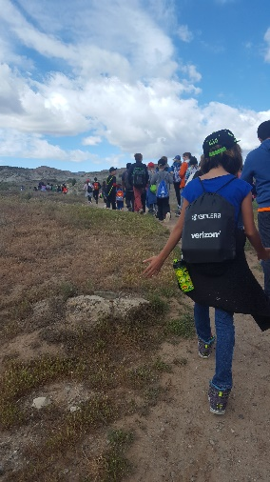
In late April, 78 fourth grade students from Lincoln Elementary in Delta took part in CCA’s various Archaeology is Awesome events. Students learned about prehistoric lifeways of native peoples from across western Colorado and how contemporary members of some of these groups, like the Ute, remain connected to their ancestral homelands in these NCAs still to this day. The learning was hands-on as students were able to create pottery using traditional pinch techniques, to learn about storytelling traditions to then develop their own, and to experience first-hand how archaic peoples used atlatls to take down big game prior to the invention of the bow and arrow.

Archeological Resource Volunteer Monitoring
This year D-E NCA was very fortunate to have the support and ability to train a new set of site stewards to work in the D-E NCA and surrounding areas. The Grand Valley Site Stewards spent a day up Big Dominguez Canyon learning to monitor sites. Participants also discussed how to visit sites appropriately and what to do when they meet members of the public who might have questions about archaeological resources in the area.
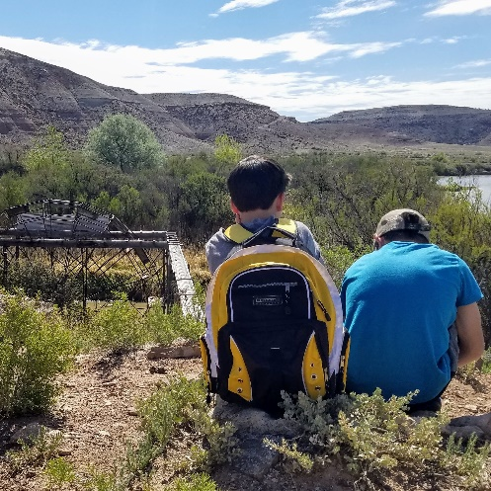
Escalante Field Experience
This year’s Escalante Field Experience, a joint venture between CCA, BLM, The Nature Connection, and Colorado Parks and Wildlife was a fantastic event. 350 seventh grade students from across Delta County participated in the event - hiking to the historic Gunnison Water Wheel, discovering dinosaur tracks in the sandstone, learning about Pinyon Jay life modes and lizard habitats, and discovering the history of American settlement in Dominguez-Escalante NCA at the Captain Smith Cabin.

Tribal Members Archaeology Workshop
Colorado Historical Society was successful at getting a National Science Foundation Grant to hold Archaeology workshops with kids from the Ute Reservations. As a part of the workshops in 2017 they visited sites in the Bennet’s Basin area of D-E NCA. This project encouraged further awareness and appreciation of Ute cultural heritage within D-E NCA, as well as providing opportunity for Ute tribal members to participate more fully in the enjoyment and protection of these special public lands.

Colorado History Day
In mid-May, CCA and BLM cosponsored a trip that taught 96 fourth and fifth grade students from the Dual Immersion Academy about the historical and cultural resources found in the Escalante Canyon Area of the D-E NCA. Students were able to explore petroglyphs, riverside ecologies, historic pioneer cabins, and mutualistic animal-plant interactions in a rigorous, standards-based way.

Nature Knowledge Days
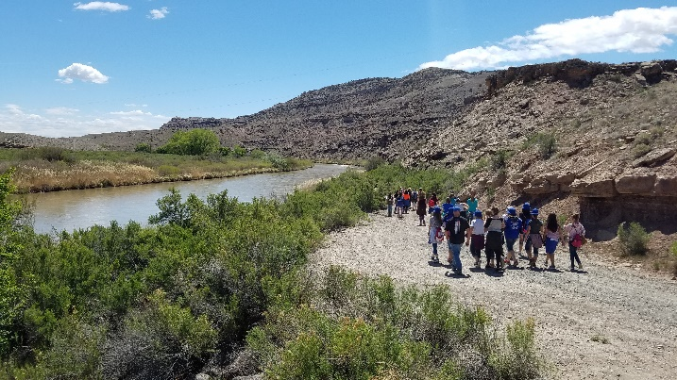
In coordination with CCA, D-E NCA launched Nature Knowledge Days for 3rd grade students in Delta County. Over the course of the week, over 215 third grade students participated, representing four different schools from within school district 50J in Delta County, into the D-E NCA. Again, students rotated between eight different stations where they explored a specific topic before receiving a stamp in their personal copy of a newly created activity book.

Hilltop Youth River Trip

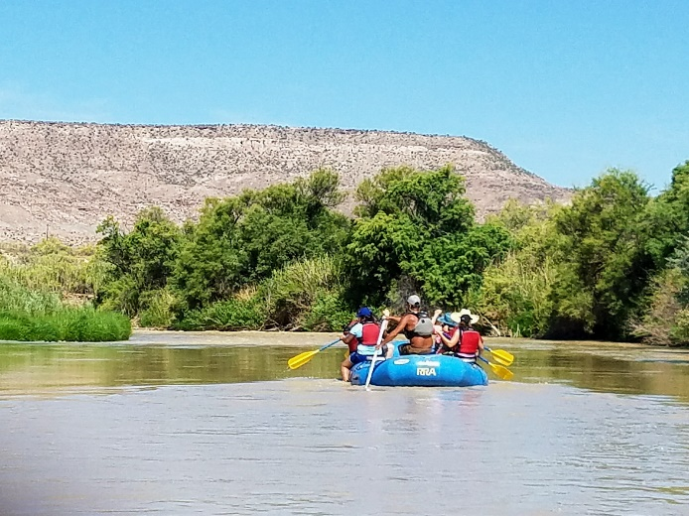
In FY 2017, CCA and the BLM took 15 students from the Residential Youth Services Program (RYS) of Hilltop on a Gunnison River rafting trip through the D-E NCA. RYS houses students who have, for the most part, been recently released by the Department of Youth Corrections. For many of the students it was their first time off the Hilltop Campus in over a year and for all of them it was their first day out in nature. For RYS students, a day on the river is an immeasurable reward for their commitment to their schoolwork and self-improvement. One student said the river trip "was the best day they've had all year." CCA is excited about the new work with Hilltop. Together, RYS, BLM, and CCA can bring the therapeutic qualities of nature to the kids that need it most.

Delta High School River Trip
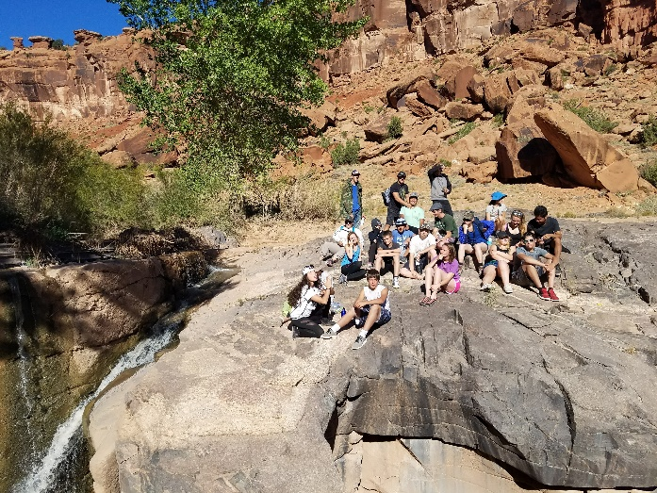
The BLM and CCA educated 23 Delta High School students as they enjoyed the beautiful canyons and archaeological sites within D-E NCA. These students are part of a district-wide program, supported by Great Outdoors Colorado (GOCO), called The Nature Connection (TNC).

On TNC trips students plan and lead. CCA works with TNC partners to provide participating students with opportunities to learn about outdoor exploration and to build their own skill sets therein. By working together on the river, students learned to paddle two-person inflatable kayaks. In camp, students took the time to recognize each other's strengths and process the day's adventures.

Partnerships
Colorado Canyons Association
Colorado Canyons Association is the friends group to the local National Conservation Areas. In FY 2017, they helped the BLM staff host river cleanups, trail monitoring classes and educational trips for our area youth. CCA provided crucial assistance in providing visitor services for the NCA at the BLM office, organizing volunteer projects, and creating awareness in the community surrounding the stewardship and management of the NCA.

Colorado Mesa University
D-E NCA staff collaborated with Colorado Mesa University (CMU) for many different projects. D-E NCA hosted several student interns from CMU’s Environmental Science Program. Interns completed assessment, inventory and monitoring studies, continued work on a plant inventory, completed rare plant monitoring, and inventoried tardigrade species.

Delta Area Mountain Bikers
The Delta Area Mountain Bikers received a grant for a conceptual trail layout and design in the Escalante Triangle Recreation Management zone. The new RMP called for development of a mountain bike trail system in this area. BLM matched the grant funds and DAMB is proceeding with layout.

Other Partnerships
The D-E NCA also closely collaborated with the Interpretative Association of Western Colorado, Colorado Parks and Wildlife, Museum of the West, Geological Society of America and Colorado Mesa University on several educational and scientific projects.

Volunteers

Janice Shepherd Receives National BLM Award

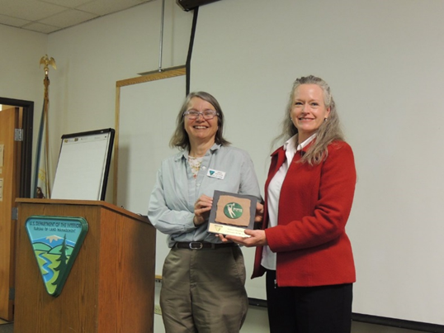
A retired computer programmer, Janice Shepherd began volunteering with the BLM in 2010, assisting cultural, range, wilderness and recreation staff with efforts throughout the Grand Junction Field Office and its two National Conservation Areas. “Her contributions over the past six years have helped the BLM fulfill its mission to be responsible public land stewards, positively impacting the local community,” said BLM Archaeologist Alissa Leavitt-Reynolds. “Janice really cares, is a very hard worker and always willing to go the extra mile.” In FY 2017 Janice received the Colorado Volunteer of the Year Award which allowed her to be considered for the Making a Difference Award. On May 21st a national panel of BLM specialists and partner representatives chose Janice for one of the Making a Difference Awards.

Gunnison River Cottonwood Caging
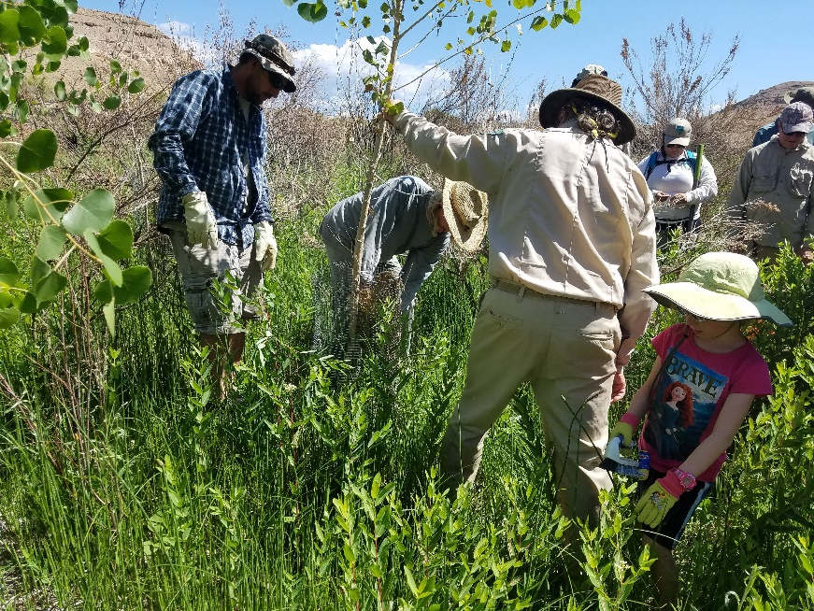
Thirteen volunteers joined the BLM River Rangers on the Gunnison River to repair wire caging around cottonwood trees. The wire caging protects the recently planted cottonwoods from herbivory by beavers and deer. This spring the Gunnison River experienced record high flows approaching 14,000 CFS. The high flows damaged many cages and cottonwoods. Fortunately, the volunteers, organized by Colorado Canyons Association, were able to repair more than 200 cages.
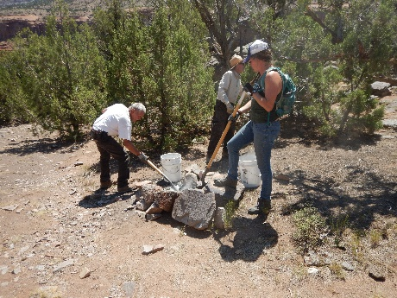
Escalante Potholes Campground Clean-up
Four volunteers, the BLM, and CCA cleared out and dismantled unofficial fire rings at this popular campsite. Altogether, the volunteers dismantled nearly 20 fire rings and removed over 500 pounds of ash.

Land (or Interests in Land) Acquisitions

Hallock Homestead Acquisition
In 2017 Congress authorized funding for the purchase of the Hallock Homestead property. This 150 acre property along the Gunnison River was purchased from the Upchurch family by Western Rivers and is being held until BLM can close on the purchase, likely in 2018.

Science
4

Bighorn Sheep
In FY 2017, CPW continued a study of Bighorn Sheep within the NCA.; this ongoing study started in spring 2012. During this time, they have been able to capture and collar 23 bighorn sheep in the area. Since the study started, four collared bighorn mortalities have occurred due to natural causes. This study will continue through 2018. 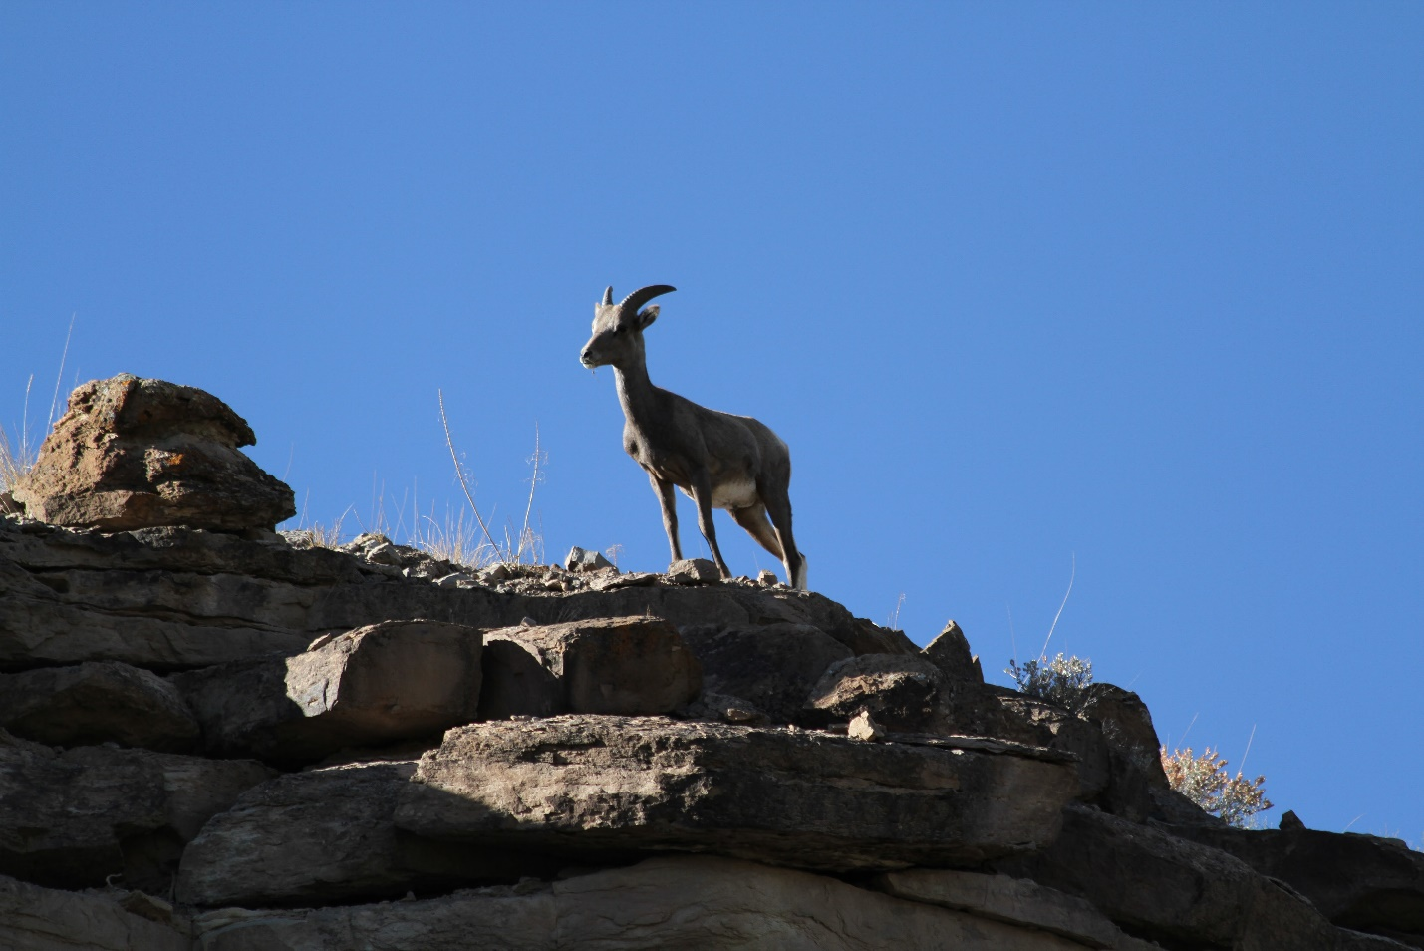

Arthoropod and Gastro-Intestinal parasites of White-tailed Prairie Dogs
In the 2017 field season, CMU faculty completed trap collections of prairie dog burrows within D-E NCA. To date, they have identified several species of biting fly black flies and culicoides, some of which maybe new records for the area. The BLM will continue to research this observation as well as continuing species identification of trap catches. As funding permits, CMU would like to continue collections at different times and continue to sort and research collected arthropods.

Survey of Species Composition and Distribution of Tardigrades in the High Desert
CMU researchers have been working to survey tardigrades found in mosses in the area and have collected specimens from the MCNCA and D-E NCA. Research is ongoing throughout both NCAs.

Salt Desert Restoration with the use of Native Shrub Species
The three NCA’s (MCNCA, D-E NCA, GGNCA) were able to leverage the National Conservation Lands (NCL) Science grant and provide funding to expand the partnership to include Colorado State University. Currently a post-doctoral student under Professor Mark Paschke is reviewing literature and past BLM treatments in salt desert habitats. This review will provide the BLM with a comprehensive review of local successes and failures on BLM lands, as well as successes and failures in other salt desert settings. With this information, the BLM can maximize the likelihood of success with native plant materials provided by the Upper Colorado Native Plant Center.

Seed Bank Survey
Again, the three NCA’s (MCNCA, D-E NCA, GGNCA) received funding from the NCL Science grants to survey the seed banks. Results will help managers determine the efficacy of seeding native plants after disturbances like fire.
Phragmites Genetic Testing
The invasive and native species of Phragmities, a reed grass, are visually identical. To determine the spread of the invasive species the Colorado Department of Agriculture funded genetic testing of samples collected throughout the state. The BLM, Mesa County Weed and Pest Management, and CCA collected Phragmites samples along the Gunnison River within the NCA. Results will be used to manage the spread of the invasive Phragmites species if present in the NCA.

Resources, Objects, Values, and Stressors
5

Natural Resources, including Biological and Environmental Values

Natural and cultural resources are among the 14 purposes of the D-E NCA listed in its enabling legislation. The NCA enjoys an extraordinary abundance of these resources, including an array of rare and common plant and animal species as well as prehistoric and historic sites and artifacts.
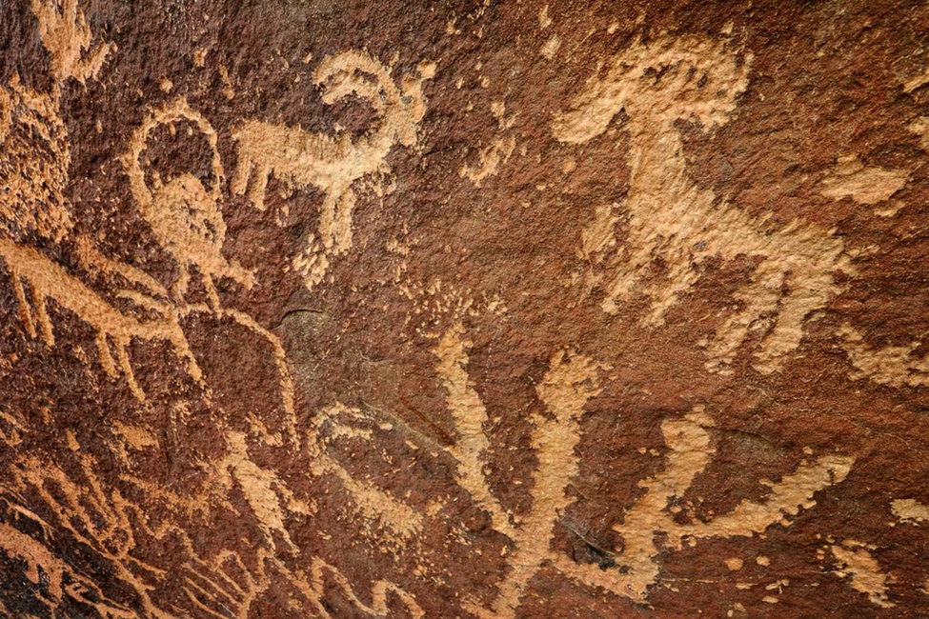

The NCA’s natural and cultural resource management staff focuses on clearly communicating the importance of conserving and protecting NCA values and expanding the BLM’s understanding of NCA resources though assessment, inventory and monitoring.

Natural and Cultural Resources Status and Trend Table

Resource, Object, or Value | Status of Resource, Object, or Value | Trend
Cultural (includes archaeological and historical) | Good | Stable
Natural | Good | Stable
Wildlife | Good | Stable
Riparian | Varies depending on species | Unknown

(Name of ROV) Inventory, Assessment, Monitoring Table

Resources, Object, or Value | Acres in Unit | Acres Inventoried | Acres Possessing Object | Acres Monitored in FY 17
Cultural (includes archaeological and historical) | 210,000 | 27,387 | 3,358 (906 sites) | 57 (15 sites)
Natural | 210,000 | 210,000 | 191,383 | 200
Wildlife | 210,000 | 210,000 | 210,000 | 130,000
Riparian | 210,000 | 179,218 | 3,330 | 2 Miles

Stressors Affecting Natural Resources
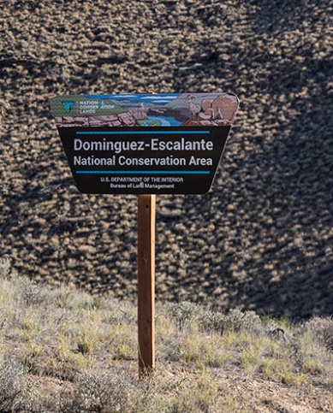
Stresses on natural and cultural resources and values include (human-caused) wildland fire, invasive plants, recreational use, improper livestock grazing and domestic livestock diseases, loss of habitat, habitat fragmentation, air pollution, non-native animals, water pollution, theft, surface disturbance, and vandalism.

Water Resources
One of the 14 purposes of the NCA listed in its enabling legislation is “the water resources of area streams, based on seasonally available flows, that are necessary to support aquatic, riparian, and terrestrial species and communities” (Section 2402 of the Omnibus Act). There are 115 miles of rivers and streams in the NCA, including the Escalante, Cottonwood, Little and Big Dominguez Creeks, and nearly 30 miles of the Gunnison River. These aquatic resources support an abundance of fish, wildlife and recreational opportunities as well as the existing water rights of neighboring landowners. BLM staff work to expand the understanding of water resources though assessment, inventory and monitoring.

Water Resources Status and Trend Table

Status of Resource, Object, or Value | Trend
Good Overall | Stable and improving

Water Resources Inventory, Assessment, Monitoring Table

Acres in Unit | Acres Inventoried | Acres Possessing Object | Acres Monitored in FY 17
210,000 | 210,000 | 17 miles | 17 miles

Stressors Affecting Water Recourses
Invasive aquatic plants, diversion, erosion, recreational use, livestock grazing, and air and water pollution may affect water resources.

Recreational resources, including Wilderness and Scenic Values
Recreation is listed as one of the 14 purposes of the NCA in its enabling legislation, and visitors to the NCA can participate in an exceptionally wide variety of recreational activities, including hunting, hiking, boating, horseback riding, off-highway vehicle (OHV) travel, rock climbing, wildlife viewing and camping. Visitors can also enjoy a broad range of recreational settings, including remote wilderness, riparian wetlands, and culturally or historically significant sites.
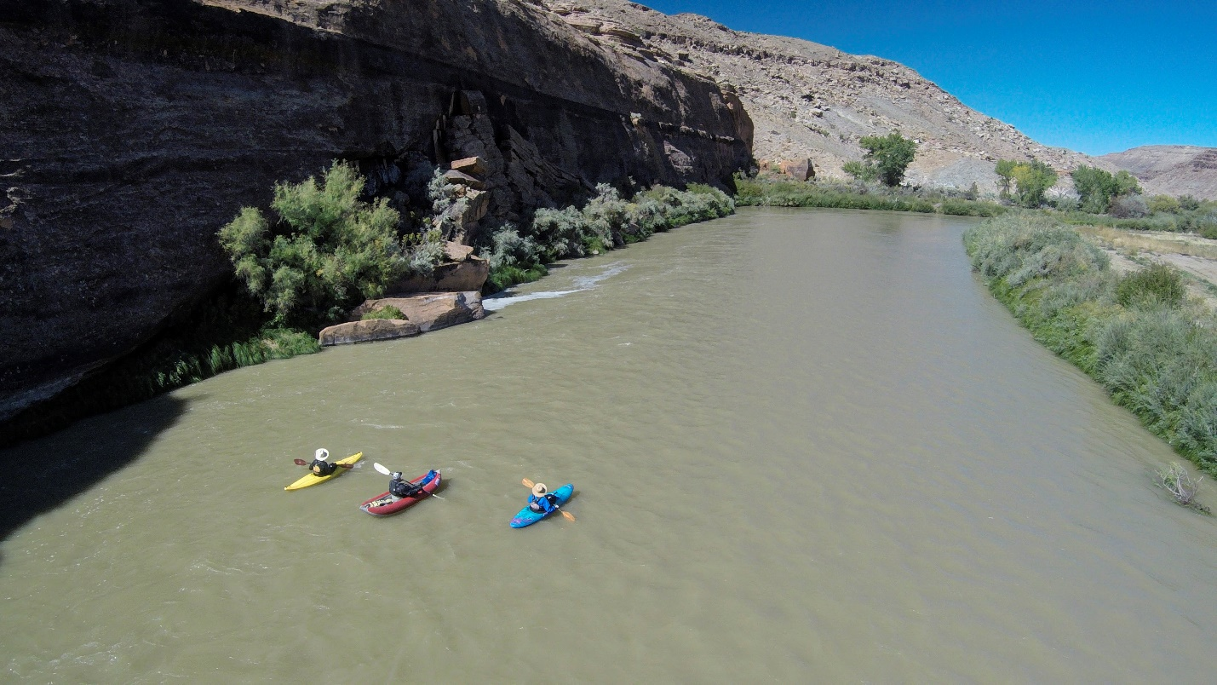
The BLM’s recreation staff assists in planning for and managing recreational resources and facilities in a manner that conserves National Conservation Lands and NCA values. Thus, roads and other facilities are built only when necessary for public health and safety, for exercise of existing rights, to minimize impacts to resources, or to otherwise further the purposes for which the NCA was designated. Recreation staff members actively engage stakeholders through the land-use planning process to help identify existing and potential uses that are compatible with the legislated purposes of the NCA, and the BLM practices a community-based approach to providing recreational services that is consistent with the purposes of the NCA and the socioeconomic goals of adjacent or nearby communities.
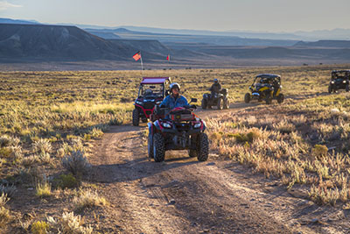
Congress designated the 66,280-acre Dominguez Canyon Wilderness in 2009 under the Omnibus Public Land Management Act of 2009. The Wilderness is located completely within the Dominguez-Escalante National Conservation Area. The BLM is committed to protect wilderness areas in such a manner as to preserve wilderness character, as well as effectively manage recreational, scenic, scientific, education, conservation, and historic uses permitted under Section 4(c) and 4(d) of the Wilderness Act of 1964.

The Dominguez Canyon Wilderness displays an array of ecosystems, ranging from upper Sonoran piñon-juniper desert along the Gunnison River, to Douglas-fir and ponderosa pine to aspen at higher elevations. Dominguez Canyon Wilderness consists of two major canyon systems, Big Dominguez and Little Dominguez. The canyons drain the northeastern corner of the Uncompahgre Plateau. Little Dominguez is the longer of the two at approximately 12 miles in length. It joins the larger Big Dominguez Canyon a little over a mile before their confluence with the Gunnison River.

The area possesses outstanding geological features, spectacular scenery, ecological diversity, two cascading mountain streams and opportunities for solitude and primitive and unconfined recreation. Large mesas dissected by deep red slick-rock canyons and arroyos characterize the terrain. The area provides valuable wildlife habitat for desert bighorn sheep, deer, elk, mountain lion, black bear, wild turkey and chukar.

The Dominguez-Escalante NCA Resource Management Plan states the goal is to preserve, protect, or enhance the qualities of wilderness character in the Dominguez Canyon Wilderness. The monitoring of wilderness character is an ongoing responsibility, and the monitoring of any changes will help to determine how stewardship decisions influence trends and prioritize actions. In 2017, staff conducted a 5-year update to the Keeping it Wild Wilderness Character monitoring protocol. The report highlighting the results of this effort are expected late winter 2018.

The practice of Visual Resource Management (VRM), in BLM land-use planning, inventories the character of a landscape according to the four basic visual elements of form, line, color, and texture. The management goal of scenic resources in D-E NCA is to protect the open spaces, the natural aesthetics, and the scenic vistas that are considered a social, economic, and environmental benefit. The entirety of the Dominguez-Escalante National Conservation Area is managed with VRM Class I and VRM Class II objectives, which are the most protective management classes. Any changes to the characteristics landscape in the NCA should be low and not attract attention.

Recreation Status and Trend Table
Resource, Object, or Value | Status of Resource, Object, or Value | Trend
Recreational | Good | Stable
Wilderness | Good | Stable
Scenic | Good | Stable

Recreation Inventory, Assessment, Monitoring Table
Resource, Object, or Value | Acres in Unit | Acres Inventoried | Acres Possessing Object | Acres Monitored in FY 17
Recreational | 210,000 | 210,000 | 210,000 | 140,000
Wilderness | 210,000 | 210,000 | 66,280 | 66,280

Stressors Affecting Recreational Resources
Recreational resources and values may be adversely affected by any of the stressors that affect natural and cultural resources, because recreational visitors to the NCA often go there expecting (for example) to see pristine habitat, healthy wildlife, or undamaged rock art. Recreational use itself can damage recreational resources where some recreational user experiences are negatively impacted by other forms of recreation. Right-of-way proximity and air pollution may also threaten the integrity of the recreational experiences.

Wilderness resources and scenic values may be adversely affected by any of the stressors that affect other resources within the National Conservation Area, with visitor use causing the greatest negative effects on wilderness character. Visitor use itself can damage the resource, especially with increased use due to local and regional population growth.

Scientific, Geological, and Paleontological Resources

The geological and paleontological resources of the NCA are listed in the NCA’s enabling legislation among its purposes, and these resources are exceptionally abundant in the NCA. Scientific study of these resources benefits the scientific community as a whole and effectively informs the BLM’s NCA management. The NCA staff works to identify research needs, encourage science partnerships and citizen science, and incorporate scientific results into management, decision-making and outreach.

BLM staff members promote the NCA to universities and research institutions as an outdoor research destination, educational laboratory and potential demonstration center for emerging technology and innovative management practices. In turn, academic institutions, aware of the unique and valuable resources in the NCA, seek out partnerships with the BLM to conduct scientific research and education in the NCA.

Scientific, Geological, Paleontological Status and Trend Table

Reource, Object, or Value | Status of Resource, Object, or Value | Trend
Scientific | Good | Stable
Geological (Precambrian to Quaternary rocks) | Good | Very Stable
Paleontological (Scientifically important vertebrate fossils | Good | Stable and Improved (more sites found every year)

(Name of ROV) Inventory, Assessment, Monitoring Table

Resource, Object or Value | Acres in Unit | Acres Inventoried | Acres Possessing Object | Acres Monitored in FY 17
Scientific | 210,000 | 90,007 | 210,000 | 200
Geological | 210,000 | 210,000 | 126,000 | 10
Paleontological | 210,000 | 158,150 | 1,507 | 50

Stressors Affecting Scientific, geological, and paleontological

Anything that affects geological, cultural, paleontological, biological, or wildlife resources affect scientific resources. Geological and paleontological resources are primarily affected by theft and vandalism.

Education

Educational resources are cited as one of the 14 purposes of the NCA in its enabling legislation, and they run the gamut of all the other resources in the NCA, which are all suitable as subjects for interpretive and educational activities.
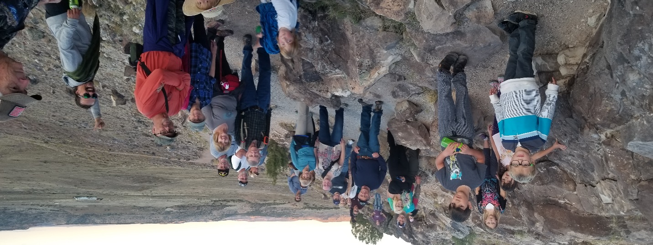
The BLM strives to provide young people with opportunities to engage in recreation, practice stewardship, and learn about NCA resources and land management. BLM staff members seek out partnerships with local schools and educators to help them interpret National Conservation Lands and NCA values. The BLM provides interpretive and educational materials to NCA users through the GJFO, UFO and the NCA website.

Education Status and Trend Table

Status of Resource, Object, or Value | Trend
Good | Stable

(Name of ROV) Inventory, Assessment, Monitoring Table

Acres in Unit | Acres Inventoried | Acres Possessing Object | Acres Monitored in FY 17
210,000 | 210,000 | 210,000 | 1000

Stressors Affecting Education
Virtually all of the resources of the NCA can be considered educational resources and are susceptible to vandalism; however, interpretive signs, kiosks and cultural sites are very susceptible to vandalism.

Summary of Performance Measure
6
.

Resources, Objects, and Values Status Summary Table
Resource, Object, or Value | Status | Trend
Cultural | Good | Stable.
Natural | Varies depending on species or habitat | Unknown
Wildlife | Good | Stable.
Riparian | Varies depending on species or habitat | Unknown
Water Resources | Varies Depending on resource | Unknown
Recreational | Good | Stable
Wilderness | Good | Stable
Scenic | Good | Stable
Geological | Good | Very Stable
Paleontological | Good | Stable and improving (more sites found every year)
Scientific | Good | Stable
Educational | Good | Stable

Manager’s Letter
7
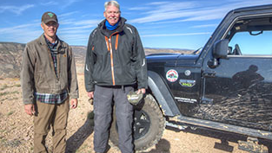
As you have seen while perusing this report, 2017 was a big year for Dominguez-Escalante National Conservation Area. This year we finished the Resource Management Plan! This long range plan will guide the management of the NCA for the next twenty or thirty years. As directed by Congress, the RMP is "a comprehensive management plan for the long-term protection and management of the Conservation Area". It "describe(s) the appropriate uses and management of the Conservation Area" and "allows (s) only such uses of the Conservation Area as the Secretary determines would further the purposes for which the Conservation Area is established."
NCA Manager Collin Ewing enjoys a day in the NCA with Advisory Council Member Bob Janowski

Dominguez-Escalante NCA provides a spectacular backdrop for several western Colorado communities. The area has long been a treasured resource for local communities, which helped craft the legislation that designated the NCA and Dominguez Canyon Wilderness in 2009. This plan will help protect the area for future generations. Under this management plan, important traditional uses of the landscape such as hunting, livestock grazing, and gold panning will continue. Approximately 206,000 acres are open to livestock grazing contributing an estimated $580,000 in labor income and 32 jobs to the surrounding communities annually. The land use plan designates 194,000 acres of new recreation management areas that will protect recreation opportunities, and provides a wide variety of motorized and non-motorized recreation opportunities. Under this plan BLM recreationists will benefit from $5.85 million worth of recreation opportunities that they don’t have to pay for and the community will get $2.1 million in labor income annually, providing for 69 jobs to local community. The plan provides a framework for improving ecological health of important biological systems like sagebrush, riparian, and salt desert communities and protects and restores habitat for key plant and animal species such as Gunnison Sage grouse, Desert bighorn sheep, and Colorado hookless cactus. It designates four Areas of Critical Environmental Concern (9,011 acres) to protect rare plants, and significant geologic and internationally significant paleontological resources like Dinosaur trackways, as well as cultural landscapes identified as important by the Ute tribes and by local ranching families. The plan ensures that BLM and partners such as Colorado Canyons Association will be able to provide high quality youth education, watchable wildlife, and auto touring opportunities, including Escalante Canyon and the Old Spanish National Historic Trail.

By far the part of the plan that drew the most interest was "the comprehensive travel management plan" required by the legislation. While the travel plan has typically been developed after the RMP, in this case we developed them concurrently. The travel plan helps to implement the larger management objectives (listed earlier above), so each tweak to the RMP requires tweaks to the travel plan as well. When it was all said and done, the travel plan designated 551 miles of travel routes open to public use (enough to get from Escalante Canyon to Mile High Stadium and back), and 407 Miles of motorized routes (enough to drive from the Mesa County line to the Denver Metro Area and back).

The plan was "developed with extensive public input" as directed by congress. In addition to four public open houses, and three public comment periods, the advisory council met 40 times (all open to the public) and the public provided thousands of comments. This gave us valuable information that improved the plan by allowing BLM to incorporate the interests of a wide variety of stakeholders including local governments, Colorado Parks and wildlife, ranchers, environmental groups, motorized and non-motorized recreationists, adjacent land owners, University researchers, and archaeologists. In fact this plan was largely a community driven effort. From drafting the legislation to forming the advisory council to development of the Approved Plan, community members provided guidance to the lawmakers and the BLM so that this plan will protect this nationally significant landscape in a way that reflects western Colorado values.

This plan ensures that D-E NCA will be an amazing place to visit, play, learn, and recharge for present and future generations of Americans. And now the long journey to implement the plan begins!

Collin Ewing,
Manager, Dominguez- Escalante National Conservation Area

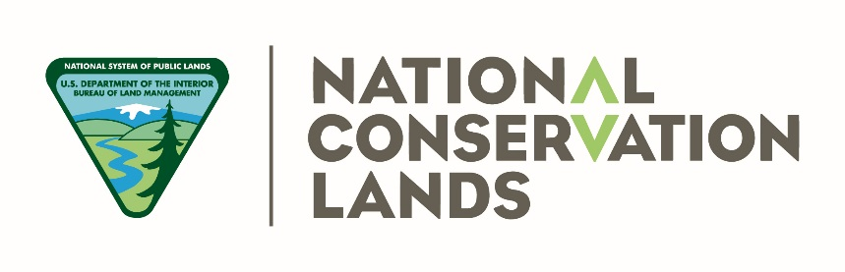
Dominguez-Escalante
National Conservation Area
Southwest District Office
Bureau of Land Management
Grand Junction Field Office
2815 H Rd.
Grand Junction, CO 81506
Phone: 970-244-3000
(11/8/2017)
The mention of company names, trade names, or commercial products does not constitute endorsement or recommendation for use by the federal government.

